**CAR WASH STATION**

**BY**

**STUDENT NAME I: ANAS AHMED ID: 362049763**

**STUDENY NAME II: RASLAN RAZOQ ID: 362051303**

**STUDENT NAME III: MOHMMED JAMAL ID: 362049583**

**Supervised by: Dr-YAZED ALSAAWY**



**Graduate project 1 (midterm report)**

**Faculty of Computer and Information Systems**

**Islamic University of Madinah**

**10/2020**

**Abstract**

Nowadays, mobile and web applications are the best way to reach customers. Using applications to perform daily tasks is now prevalent. So the developers always try to present the best app to make your life more comfortable. So, we thought to provide an application that would make it easier for customers to request a car wash service or book before going to the laundry, evaluate the service provided, and many advantages. We will use a flutter framework to program our application to ensure access to the largest segment of customers, and the control panel will be built using Laravel framework.

**CAR WASH STATION**

**Chapter 1**

**1.0 Introduction:**

Car washing systems are the systems being used for cleaning the exteriors and interiors of the cars. It facilitates easy washing and cleaning of the automobile. The growth in automotive industry leads to an increase in demand for the car wash systems. The other factors driving the growth of the car wash systems market are the increase in production and sales of vehicles, reduced instances domestic car washing, and high disposable income. Also, the growth of the market is driven by features such as improved efficiency, higher safety, easy management, reliability, customers satisfaction and time efficiency.

Car washing systems are very common in developed countries and industrialized countries. These systems are fully automated with different stages of rinsing, shampooing, washing, and drying. Consumers are becoming more aware of the benefits of car wash services such as improved efficiency and safety. Also, the increasing environmental awareness among people is driving the growth of car wash services, which ensures optimal deployment of water resources and proper dumping of solid waste, thus helping the growth of market for car wash systems.

There are many car washes in Saudi Arabia and the world as it is considered one of the successful small projects if it has strict management and excellent work. The types of laundries differ in terms of traditional, automatic and mobile. In addition, the mobile washing cars demand is growing day by day. From here came the idea of ​​the system and the mobile application where I can limit the collection of most types of the existing car washers in one place so that he can Customer choose from and choose the one appropriate for him.

**1.1-Aim:**

An application that will allow the user (customer) to request service, to book the car washing service at a certain time of the day (along with other washing options). The car wash station will provide the real time availability of the service and give the customer update on when he can reserve, and the nature of the service needed and the mode of payment.

**1.2-Overview:**

The overall outlook over the system of the car wash have two main parts, the first part is for booking car wash services online, and the second one is for the owners and managers of the car wash to control the business, review workers, and provide full reports for all processes. In the current system, it’s an old school system, without any management technics so costumer now dealing with varying issues when cleaning their cars with the normal car wash, example of issue may costumer face such as time-consuming.

**1.3-Problem statement:**

1. The crowding and the time wasting at car wash line
2. To know the specific sold time for every car wash
3. Know types of specific services
4. Review the quality of worker
5. Finding the nearest car wash to customers and evaluating quality

**1.5-Objectives:**

The main objective of the car wash system is making car wash service full automated form the costumer reservation to paying and reviewing the service

Sub-objectives are:

1. Knowing and reviewing the evaluation of customers in the car wash application in terms of services provided and offers.
2. Provide home car cleaning service.
3. Customer knowledge of the car wash status, whether it is occupied or not.
4. The ability of the customer to book the most appropriate time and date.
5. Prepare and providing a car wash for the type of service required and chosen by the customer
6. provide several payment methods for user, and the ability to pay remotely.
7. Locate the location of car washes.
8. Reduce the annoying crowd at car washes.
9. Specify the period of time for cleaning car process.
10. Opportunity for review and feedback about the service.
11. Daily inventory for car wash productivity.
12. Feedback about for specific worker services.
13. Provide opportunity for freelancer services.
14. Creates smart systems for measuring wasting water in car washing process
15. Linking all services with transporter service providers.
16. Unified the car wash systems

**1.6-Gantt chart:**

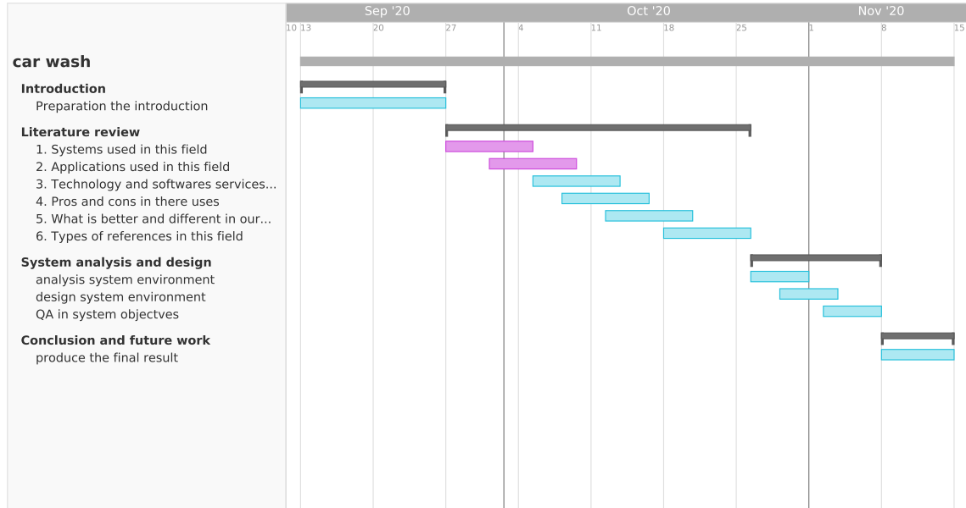

Figure (1) Gantt chart

**1.7-Framework:**

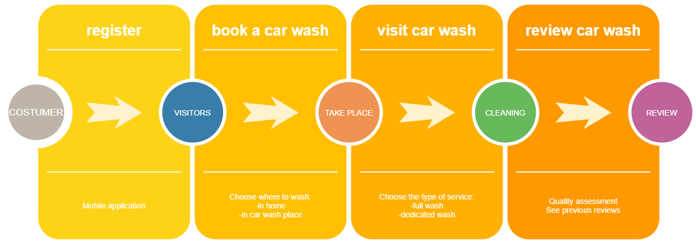

Figure (2) Framework

**Chapter 2**

**2.2-Literature review:**

**2.2.0-Focus in the project:**

We need to concentrate on part of the social issues that waste time in them, we have found that the registration and reservation mechanism for appointments is the mechanism that really needs to be improved and converted to the online system, and that is what we are going to improve in the original system.

**2.2.1-Overview of technology:**

In general the society has turned into be based on the technology in many aspects, and the mobile and web applications are the best way to reach customers, since this situation become part of our way of life there is a high number of the population have a smart phone/tablet using applications to perform daily tasks is now prevalent that provide to an accessibility to the internet. The car wash domain is far away from web and applications technologies at this moment but it will be big change and real challenge.

**2.2.2-Literature review:**

**2.2.3-The technology:**

**Flutter:**

Flutter is a free and open-source mobile UI framework created by Google and released in May 2017. In a few words, it allows you to create a native mobile application with only one codebase. This means that you can use one programming language and one codebase to create two different apps which are dart, we use it because it will make the mobile programming phase faster at first and it has good community will give us more futures in future.

**Laravel php framework:**

Laravel is a free, open-source PHP web framework, created by Taylor Otwell and intended for the development of web applications following the model–view–controller (MVC) architectural pattern and based on Symfony. Some of the features of Laravel are a modular packaging system with a dedicated dependency manager, different ways for accessing relational databases, utilities that aid in application deployment and maintenance, we use Laravel because it’s a high security and has many packages that will improve our work at backend with the APIs are available for free.

**Database:**

MySQL server is a SQL complaint server, And it’s have a major advantages that it’s free, and we use it because it’s have a high data security, have a high performance, On-demand scalability, and the flexibility of open source , also MySQL is based on a Client-Server model.

**2.2.4-Past experience:**

**2.8.1 1. Ghaseel app:**

it is an application that allows car wash service providers to display their services in the application and allows customers to review and request laundry service for the place specified by the customer.

How Ghaseel works:

1) The customer specifies the location of the car to be washed.

2) Determine the type of vehicle

3) Browse the available laundries to request the service

4) paying off

5) Rating

The services provided by the washing application:. [5]

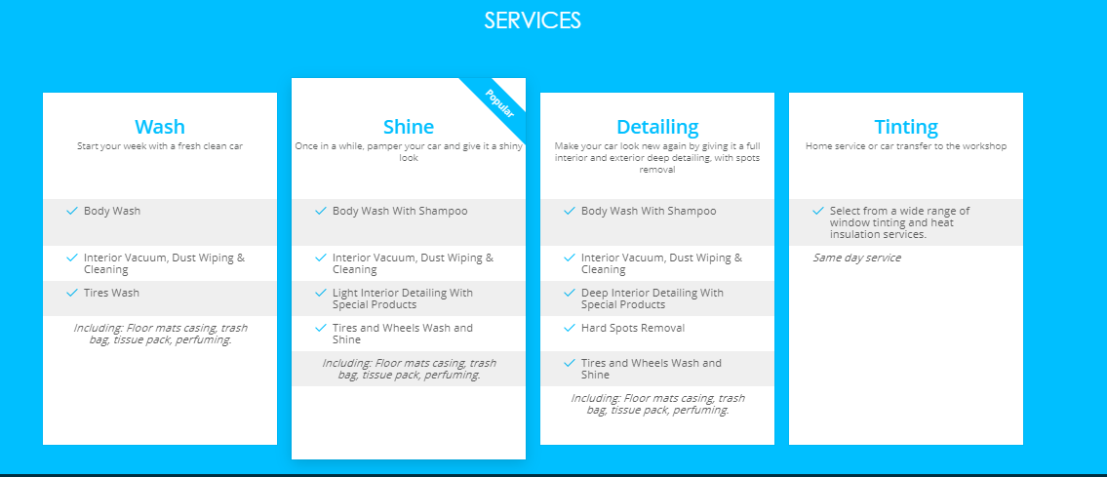

**2.8.2 Sayar app:**

It is an application that connects mobile service providers with customers in one place and allows customers to choose various car care services at different prices to implement them at the time and place that suits them. .[6]

How Sayar works:

1) The customer specifies the place and time for the service.

2) Choose the service and package provider.

3) paying off

4) Rating

Both above apps are for mobile laundry companies only

**References:**

1. [http://www.ghaseel.com](http://www.ghaseel.com/)
2. [https://sayarapp.com](https://sayarapp.com/)